LOCAL GOVERNMENT UNIT 4: DISASTER PREPAREDNESS TRAINING AND SIMULATION WITH AI SCENARIO AUTO-GENERATION USING GEMINI API

A Capstone
Presented to the Faculty of
The College of Computer Studies
Bestlink College of the Philippines

In Partial Fulfilment
of the Requirements for the Degree
Bachelor of Science in Information Technology

CHEINARD R. AQUINO
REYMON S.A BROGADA
JOHN BENEDICT S. FANER
ERIC A. PASTOR
MARC DAVE S. VALDEZ

February 2026
APPROVAL SHEET

This capstone entitled LOCAL GOVERNMENT UNIT 4: DISASTER PREPAREDNESS TRAINING AND SIMULATION WITH AI SCENARIO AUTO-GENERATION USING GEMINI API, prepared and submitted by CHEINARD R. AQUINO, REYMON S.A BROGADA, JOHN BENEDICT S. FANER, ERIC A. PASTOR, MARC DAVE S. VALDEZ, in partial fulfilment of the requirements for the degree of Bachelor of Science in Information Technology, has been examined and is recommended for acceptance and approval Oral Defense.

RICHELYN A. VILLASOR
Adviser
CAPSTONE REVIEW PANEL
Approved by the Committee on Oral Examination with a grade of

LASER RYAN V. LLENO, MSIT VINCENT CARLO T. GARADOS
Member Member

JUNNEL E. AVESTRO, DIT
Chairperson

Accepted and approved in partial fulfillment of the requirements for the degree of Bachelor of Science in Information Technology.

ROSICAR E. ESCOBER, Ph. D
Dean, College of Computer Studies
Date of Pre-oral Defense:
ACKNOWLEDGEMENT
The researchers would like to express their heartfelt thanks and gratitude to the following persons who, in one way or another, has contributed much, and extended willingness and support needed to make this research possible:
Dr. Maria M. Vicente, President/CEO, Bestlink College of the Philippines, for her generosity and kind heart in establishing this institution and giving opportunities to those less fortunate students to continue their studies and pursue their dreams;
Ms. Edith M. Vicente, Executive Vice President, for providing the needed information to complete this research;
Dr. Charlie I. Cariño, Vice President for Academic Affairs, for his support and encouragement to make this thesis writing possible;
Engr. Diosdado T. Lleno, Vice President for Administration and
Finance, for his words of encouragement and motivation;
Dr. Joy Evelyn A. Ignacio, College Associate Research Head, for her good heart to extend her help needed by the researchers.
Dr. Rosicar E. Escober, Dean, College of Computer Studies of Bestlink College of the Philippines, for providing a guideline documentation in capstone project.
Dr. Rommel J. Constantino, Program Head, Bachelor of Science in Information Technology, for the constant supervision as well as providing necessary information regarding the project and also for his support in completing this project
Ms. Richelyn A. Villasor, Research Coordinator, for helping us in improving our research and guiding us in completing this project.
Ms. Richelyn A. Villasor, Capstone Adviser, for giving us suggestions and ideas to improve our research and guiding us in completing this project.
Panelists, Mr. Vincent Carlo T. Garados, Engr. Reynante B. Ponay, and Dr. Rommel J. Constantino, who extended their effort and time to be able to constructively criticize this thesis and share their knowledge with them to deepen and widen their needed information.
Families and Friends, for all the financial and moral support that have enabled the researchers to triumph all the challenges, especially during the lowest time that served as their inspiration to complete this study; and
Above all, to the Almighty God, for the strength and knowledge that were used for the accomplishment of this research journey.

THE RESEARCHERS
DEDICATION
This business research study is wholeheartedly dedicated first and foremost to the researchers, for executing dedication, time, effort, motivation, sacrifice, and courage to make this conducting study a fruitful and successful piece of work.
To our beloved parents who have been our inspiration and gave us strength when we thought of giving up, which continually provide their moral, spiritual, emotional and financial support.
To each sibling and circle of friends who shared their words of advice and encouragement to finish this study.
To the research advisers and professors, for extending help by giving guidance, supervision, time and wisdom to the researchers in conducting this business research study.
And lastly, above all, to our Almighty God, for giving guidance, strength, power of mind, protection, skills and for giving us a healthy life. All of these we offer to you.
THE RESEARCHERS

ABSTRACT
Title: LOCAL GOVERNMENT UNIT 4: DISASTER PREPAREDNESS TRAINING AND SIMULATION WITH AI SCENARIO AUTO-GENERATION USING GEMINI API
Authors: CHEINARD R. AQUINO
REYMON S.A BROGADA
JOHN BENEDICT S. FANER
ERIC A. PASTOR
MARC DAVE S. VALDEZ
Degree: Bachelor of Science of Information Technology
Major: Information Management, Information Security
Date of Completion:

IMRAD TYPE Lorem ipsum dolor sit amet, consectetur adipiscing elit, sed do eiusmod tempor incididunt ut labore et dolore magna aliqua. Ut enim ad minim veniam, quis nostrud exercitation ullamco laboris nisi ut aliquip ex ea commodo consequat. Duis aute irure dolor in reprehenderit in voluptate velit esse cillum dolore eu fugiat nulla pariatur. Excepteur sint occaecat cupidatat non proident, sunt in culpa qui officia deserunt mollit anim id est laborum
Lorem ipsum dolor sit amet, consectetur adipiscing elit, sed do eiusmod tempor incididunt ut labore et dolore magna aliqua. Ut enim ad minim veniam, quis nostrud exercitation ullamco laboris nisi ut aliquip ex ea commodo consequat. Duis aute irure dolor in reprehenderit in voluptate velit esse cillum dolore eu fugiat nulla pariatur. Excepteur sint occaecat cupidatat non proident, sunt in culpa qui officia deserunt mollit anim id est laborum.

TABLE OF CONTENTS
Page
TITLE PAGE i
APPROVAL SHEET ii
ACKNOWLEDGMENT iii
DEDICATION v
ABSTRACT vi
TABLE OF CONTENTS viii
LIST OF TABLES xiii
LIST OF FIGURES xiv
LIST OF APPENDICES xv
CHAPTER
1 INTRODUCTION
1.1. Background of the Capstone Project 1
1.2. Context and Scope 3
1.3. Problem Statement 7
1.4. Objectives and Goals 8
1.5. Significance and Relevance 10
1.6. Structure of the Document 12

CHAPTER
2 REVIEW OF RELATED LITERATURE
2.1. Agile Scrum Methodology Overview 14
2.2. Enterprise Architecture Concepts 16
2.3. Microservices Architecture 18
2.4 DevOps and CI/CD 18
2.5 Relevant Studies and Research 20
2.6 Integration of Information Systems in 24
Enterprise Environment
CHAPTER
3 METHODOLOGY
3.1. Agile Scrum Methodology in the Project 25
3.2. Roles (e.g., Scrum Master, Product Owner, 27
Development Team)
3.3. Sprint Cycles (e.g., Sprint Planning, 31
Daily Standups, Sprint Review)
3.4. Scrum Artifacts 37
3.5 Microservices Architecture 77
3.6 DevOps Implementation 82
3.7 Integration Approach for Information Systems 87
3.8 Introduction to TOGAF and the Four 90
Architectural Domains
CHAPTER
4 REQUIREMENTS ANALYSIS
4.1. Stakeholder Identification
4.2. Requirements Gathering Techniques
4.3. User Stories and Use Cases
4.4. Functional Requirements for Integration
5. Business Process Architecture
5.1. Identification of Business Processes
5.2. Business Process Diagrams
5.3. Alignment of Integrated System with
Business Processes
5.4. Business Process Improvements
6. Application Architecture
6.1. Components of Application Architecture
6.2. Application Architecture Diagrams
6.3. Integration of Software Modules
6.4. Communication and Interaction Patterns
7. Data Architecture
7.1. Data Sources and Types
7.2. Data Flow Diagrams
7.3. Data Storage and Management
7.4. Data Synchronization Across Systems
8. Technology Architecture
8.1 Technology Stack and Infrastructure
8.2 Software Technologies
8.3. Scalability and Performance Considerations
9. Development Process
9.1. Agile Scrum Roles and Responsibilities
9.2. Sprint Planning and Backlog Management
9.3. Sprint Execution and Deliverables
9.4. Challenges Faced In the Development Process
10. Implementation
10.1. Technical Implementation Details
10.2. Tools and Technologies Used
10.3. Code Integration and Interoperability
10.4. Integration Testing and Debugging
11. Testing and Quality Assurance
11.1. Testing Strategies and Methodologies
11.2. Test Cases and Test Data
11.3. Test Results and Bug Reports
11.4. Quality Assurance Measures
12. Results and Evaluation
12.1. Project Outcomes and Deliverables
12.2. Alignment with Project Objectives
12.3 Stakeholder and User Feedback
12.4. Lessons Learned
CHAPTER
5 CONCLUSION
13.1. Key Takeaways and Summary
13.2. Project Achievements and Contributions
13.3. Future Work and Enhancements
13.4. Closing Remarks
REFERENCES
APPENDICES
CURRICULUM VITAE

LIST OF TABLES
Table Page
- Roles and Responsibilities 27
- Sprint Cycle 33
- Product Backlog (User Stories) 37
- Product Backlog for EIS Information Security 47
- Product Backlog for EIS Standards 49
- Product Backlog for EIS Integration 51
- Product Backlog for Analytics 56
- Product Backlog for EIS Analytics 58
- Sprint Backlog (User Stories) 60
- Scrum Board 73

LIST OF FIGURES
Figure Page
- Agile Scrum Framework 26
- Burndown Chart 76
- Microservices Diagram 79
- Communication Pattern 80
- Data Flow Diagram 81
- CI/CD Pipeline 85
- Infrastructure as a Code (IaC) 85
- Monitoring and Alerting 86
- Integration Diagram 88
- API Gateway 88
- Data Flow Diagram 89
- Use Case Diagram 92
- Sequence Diagram 93
- Flowchart 93

LIST OF APPENDICES
Appendix A Detailed Technical Documentation
Appendix B Documents/URLs
Appendix C Certificate of Originality
Appendix D Certificate of Grammarian
Appendix E Grammarian Curriculum Vitae
Appendix F Technical Adviser Curriculum Vitae
Appendix G Research Adviser Curriculum Vitae
Appendix H Researcher’s Curriculum Vitae

Chapter 1
INTRODUCTION
1.1 Background of the Capstone Project
Disasters whether natural or human-made continue to pose serious challenges across the world. In the Philippines, Local Government Units (LGUs) play a critical role in ensuring community safety and preparedness. Barangay San Agustin, Novaliches, Quezon City, is no exception. Despite its ongoing efforts, the barangay still faces difficulties in delivering effective disaster response and mitigation due to challenges such as limited resources, outdated procedures, and insufficient training for disaster management personnel.
Traditional disaster preparedness training within the barangay often relies on manual simulations. While these activities provide essential learning, they also come with several limitations. Scenarios are typically fixed and lack flexibility, making it difficult to adjust to real-time changes such as evolving weather conditions, varying disaster intensities, or shifts in human behavior. The effectiveness of these simulations also heavily depends on the facilitators’ experience and creativity, which can result in repetitive or predictable scenarios that do not fully assess the readiness of the response teams.
As disasters grow more frequent and more severe, the need for Barangay San Agustin to adopt more effective and adaptable preparedness methods becomes increasingly urgent. The barangay must be equipped to respond to a wide range of emergencies from typhoons and flooding to earthquakes, fire incidents, and other hazards using training exercises that reflect dynamic, realistic, and complex situations.
However, designing such diverse and detailed scenarios manually requires significant time and resources. This underscores the need for a solution that can automatically generate realistic disaster scenarios without adding pressure to the barangay’s limited manpower. This is where Artificial Intelligence (AI) can provide meaningful support.
The Gemini API, an advanced AI technology, offers a promising approach to enhancing disaster preparedness training. It can generate highly detailed, realistic, and adaptable disaster scenarios in real time. Through machine learning, it can adjust simulations based on environmental data, geographic conditions, and probable human responses. This results in training environments that are far more dynamic and unpredictable compared to traditional methods.
Integrating the Gemini API into Barangay San Agustin’s disaster preparedness program would allow the barangay to conduct more frequent, diverse, and immersive training sessions. The system’s ability to process a wide range of variables helps create scenarios that evolve with changing conditions effectively challenging response teams to make quick, informed decisions under realistic pressure. Additionally, AI-powered simulations are more cost-effective and scalable, reducing the time and resources needed to produce high-quality training exercises.
By adopting AI-generated scenario simulations, Barangay San Agustin, Novaliches, Quezon City, can significantly strengthen its disaster preparedness capacity. This approach can enhance team readiness, improve resource management, and ultimately contribute to protecting the lives and safety of its residents during emergencies.

1.2 Context and Scope
The project is initiated within the critical operational framework of Local Government Unit 4 (LGU 4), a jurisdiction facing frequent threats from Flooding and Typhoons, Fires. Effective and timely disaster response is paramount, yet traditional preparedness drills often suffer from:
      - Repetitiveness: Scenarios are static and predictable, leading to rote memorization rather than adaptive decision-making.
      - Limited Scope: Drills rarely cover the full spectrum of complex, cascading failures common in real-world events (e.g., simultaneous communications failure and infrastructure damage).
To address these shortcomings, this project proposes the development of a web-based training platform. This platform is strategically designed to shift the LGU's focus from mere procedural compliance to adaptive decision-making under pressure. By integrating the Gemini API for automated scenario generation, the environment will dynamically introduce localized, novel, and diverse challenges, thus significantly enhancing the LGU's response capabilities and overall resilience against unpredictable disasters.

Scope (Inclusions)
The following deliverables and activities are included within the project's scope:
- Design and Development of a Functional Simulation Platform: Creation of a secure, web-based system capable of hosting and running disaster response scenarios.
- Integration of the Gemini API for Scenario Auto-Generation: Implementation of the Google Gemini API to automatically generate diverse, geographically localized, and technically complex disaster scenarios tailored for LGU 4.
- Development of a Scoring Mechanism: Creation of a quantitative system to evaluate LGU personnel response decisions, timelines, and resource allocation effectiveness during the simulation.
- Validation through a Pilot Training Session: Execution of a formal pilot simulation session with select LGU 4 personnel to test the platform's functionality and validate the effectiveness of the training methodology.
Exclusions (Out of Scope)
- Full Integration with LGU's Actual Operational Disaster Monitoring Systems: The platform will use static or pre-determined data points for the simulation; it will not integrate with real-time external data feeds (e.g., live weather feeds, actual infrastructure monitoring).
- Deployment to Other Local Government Units (LGUs): The system's design and deployment are strictly limited to LGU 4.
- Development of a Virtual Reality (VR) or Augmented Reality (AR) Environment: The training platform will be entirely web-based (standard 2D interface) and will not include any immersive VR or AR components.

1.3 Problem Statement
Local Government Unit 4 (LGU 4) currently faces a critical gap in its disaster preparedness strategy: existing simulation and training protocols are static, resource-intensive to update, and fail to adequately prepare personnel for the complex, diverse, and unpredictable nature of multi-hazard disaster scenarios.
Specifically, the problem is threefold:
1. Lack of Scenario Diversity and Realism: Current drills are often based on predictable, repetitive scripts, which leads to procedural complacency among personnel rather than fostering adaptive, critical decision-making required when faced with cascading failures (e.g., simultaneous infrastructure damage, communication outages, and mass displacement).
2. Inefficient Scenario Generation: The manual creation, validation, and maintenance of diverse, localized training scenarios consume excessive time and human resources, limiting the frequency and quality of preparedness exercises.
3. Subjective Performance Evaluation: The absence of a standardized, quantitative scoring mechanism results in subjective after-action reviews, making it difficult to objectively measure improvements in LGU response competency over time.
This project, utilizing the Gemini API for automated scenario auto-generation, directly addresses this deficiency by creating a dynamic, scalable, and objective simulation environment to ensure LGU 4 personnel are trained to handle the full spectrum of high-stakes, localized, and complex disaster events.
1.4 Objectives and Goals
Objectives (Specific Outcomes for LGU Personnel Readiness)
The immediate mission is to equip LGU 4 personnel with the best possible tools, ensuring they are prepared for the unpredictable challenges of a real disaster. We aim to achieve:
- A Reliable Training Sandbox: To build and launch a flexible, web-based simulation platform that acts as a safe, high-stakes training environment where LGU teams can practice critical decisions without real-world risk.
- Training by AI Innovation (The "Unpredictability Factor"): To successfully integrate the Gemini API so that the system can instantly create new and unique disaster scenarios every time—preventing predictability and forcing personnel to think on their feet, just as they would during a real emergency.
- Stress-Testing the System and the Team: To rigorously test the platform by running at least ten distinct, complex disaster scenarios (like a massive coastal storm combined with a total communications blackout), proving the system can generate realistic chaos and that the teams can respond effectively.
- Making it User-Friendly and Effective: To hold a pilot training session and actively listen to the feedback from LGU 4 personnel, ensuring the scenarios feel real and the training is valuable, not just a technical exercise.
Goals (Broader Aims for Community Safety and Resilience)
The long-term vision is to transform how LGU 4 protects its citizens and to set a new standard for government preparedness everywhere:
- Saving Lives Through Better Decisions: To significantly enhance the real-world preparedness and speed of decision-making among LGU personnel, ultimately leading to faster, more effective responses during actual crises, minimizing damage, and saving lives in the community.
- Creating a National Model for Smarter Training: To establish LGU 4 as a pioneer, demonstrating that accessible AI technology can revolutionize emergency management training, providing a practical blueprint that other local governments can easily adopt to boost their own community resilience.
1.5 Significance and Relevance
LGU 4 and the Community
This project is about giving LGU 4 the tools to protect its people better. It means:
- Confidence in Crisis: Instead of repeating the same old drill, LGU personnel can practice against thousands of unique, realistic situations (like training in a flight simulator). This builds their muscle memory for complex decision-making, ensuring they feel confident and ready when the real disaster hits.
- Smarter, Faster Response: The low-cost, repeatable nature of the platform means the team is always sharp. When a storm or seismic event occurs, this project helps ensure their response is faster, clearer, and more effective, leading directly to fewer injuries and better outcomes for the community.
- Learning with Precision: The platform provides clear, objective feedback ("You wasted 30 minutes deploying the wrong asset here"). This replaces subjective guesswork with precise data, helping team members genuinely learn from their mistakes and improve every single time they train.
Disaster Risk Reduction and Management (DRRM) Community
This project isn't just for LGU 4; it's a demonstration for everyone in emergency response that better training is now possible:
- Freeing Up Experts' Time: We show that Generative AI (Gemini API) can take over the tedious, manual work of constantly inventing new disaster scenarios. This frees up experienced emergency managers to focus on strategy, policy, and direct community engagement, rather than just writing scripts.
- Championing Realistic Training: We are proving that adaptive, unpredictable training is the future. This inspires other government units to adopt similar modern, technology-driven approaches, helping all communities move toward a higher level of collective resilience.
Capstone Development Team
For the students building this platform, this is more than just a grade it's a launchpad for their careers:
- Building the Tech of Tomorrow: They gain hands-on experience building complex, real-world systems (using the microservices approach) and integrating the newest, most exciting technology, the Gemini API. This is practical, in-demand experience that goes far beyond the classroom.
- Making a Difference: The team gets the satisfaction of knowing their hard work is directly contributing to a vital public service helping a real government unit save lives. They apply their technical skills to solve a significant human challenge.

1.6 Structure of the Document
This document is organized into five distinct chapters, each focusing on a specific phase of the research and development process:
Chapter 1: Introduction - Provides the foundational context of the study, including the problem statement, objectives, significance, and the scope and limitations of the project.
Chapter 2: Review of Related Literature - Explores existing research, historical data, and technological advancements relevant to the project. This section places the current work within the broader context of the field and identifies gaps the project aims to fill.
Chapter 3: Methodology - Details the research design, data collection methods, and the technical approach used to achieve the project goals. It serves as a roadmap for how the study was conducted.
Chapter 4: Requirement Analysis - Outlines the functional and non-functional requirements of the system. This chapter breaks down user needs, technical specifications, and the constraints governing the final solution.
Chapter 5: Conclusion and Recommendations - Summarizes the key findings and outcomes of the project. It also provides actionable recommendations for future research or system enhancements based on the results obtained.

Chapter 2
REVIEW OF RELATED LITERATURE
2.1 Agile Scrum Methodology Overview
Scrum is simply a structured way for a team to build complex things step-by-step, working closely with the client. Instead of trying to plan the entire project for a year and hoping nothing changes, Scrum breaks the work into short, intense bursts called Sprints (usually 2-4 weeks). At the end of every Sprint, we deliver a small, functional piece of the simulation platform.
The core idea is: Work with speed, show what you’ve built, and adapt immediately based on feedback. It’s about being flexible and focusing on continuous improvement.
Why Scrum Works for This Project
We need Scrum because our project has two big unknowns:
  - The New Technology Challenge: Integrating the Gemini API is cutting-edge. We don't know exactly how LGU data will best connect with the AI right from day one. Scrum lets us test the connection in a short Sprint, see what works, fix what doesn't, and keep moving forward without getting stuck. It allows for smart experimentation.
  - Making Scenarios Feel Real: The most crucial test is whether the LGU personnel feel the scenarios are realistic. With Scrum, we don't wait until the end to show them the platform. Every few weeks, we can demo new scenarios and ask: "Does this feel like a real disaster? What needs to change?" This constant, hands-on feedback loop with the LGU team guarantees we build a training tool they actually need and trust.
How We Work Together (The Scrum Roles)
- The Voice of the LGU (Product Owner): This person represents the training needs of LGU 4. They tell the team what is most important to build next for effective disaster preparedness.
- The Team Coach (Scrum Master): This person helps the development team stay focused and removes any roadblocks whether technical issues or confusing requirements so the team can work smoothly.
- The Builders (Development Team): This is the Capstone team that designs, codes, and tests the platform. They decide how to turn the LGU's needs into a working piece of software every Sprint.
In short, Scrum is the project's foundation that guarantees collaboration, adaptation, and rapid learning, ensuring the final platform is effective, relevant, and fully accepted by the LGU users.

2.2 Enterprise Architecture Concepts
Before we write a single line of code, we need a reliable plan. Enterprise Architecture (EA) is simply our way of making sure our cutting-edge AI training system isn't just a cool tech demo, it's a sustainable, smart solution that genuinely fits how the LGU works.
Think of EA as the Master Plan that guarantees our LGU's mission (fast, effective disaster response) is perfectly aligned with the technology we build (our Gemini API system).
A. Our Core Mission: Bridging the Gap
Our main goal with EA is to draw a clear line from where the LGU is right now (their current training methods) to where they need to be in the future (using our smart, dynamic AI simulations).
- It's about the Big Picture: It stops us from building something amazing that, six months later, doesn't connect to their existing data or IT infrastructure.
B. The Four Cornerstones of Our Design
To make sure we don't miss anything, we analyze the LGU's organization through four simple lenses (our "domains"):
- Business Architecture (The "People & Process" Plan):
- Focus: We start with the LGU's current manual: How do they respond to a flood? We model their existing disaster protocols, organizational hierarchy, and training needs.
- Goal: To ensure our simulation tool directly supports and improves the exact steps LGU personnel need to take when a real disaster hits.
- Data Architecture (The "Information Flow" Plan):
- Focus: We look at all the crucial data: historical incident reports, LGU personnel lists, and the hazard maps.
- Goal: To design a data structure that allows the Gemini AI to pull in relevant real-world data to create realistic scenarios and, critically, ensures that the training feedback data is stored securely and accessibly.
- Application Architecture (The "Software Blueprint" Plan):
- Focus: This is the map of our software. It defines the Training Platform itself, the Reporting Module, and how these pieces integrate.
- Goal: To show precisely how the Gemini API is plugged into the main simulation platform—minimizing complexity and ensuring a smooth, reliable exchange of information.
- Technology Architecture (The "Infrastructure" Plan):
- Focus: The fundamental technology underneath it all: the cloud server, the network connection, and the specific version of the programming language.
- Goal: To set the technical standards (e.g., security, performance) that guarantee the platform can handle many users running complex simulations without crashing.
C. Why Frameworks Matter
Using established guidelines (like TOGAF) means we don't have to invent our design process. It forces us through a structured cycle (the ADM), ensuring we systematically check all four domains before we move to development.
- The Capstone Value: This formal approach makes our Capstone project far more professional. It proves that our technical solution is not just an isolated piece of software, but a strategic asset designed to integrate seamlessly into a real-world organization.
2.3 Microservices Architecture
Imagine the old way of building software (a Monolith) was like building a single, giant, multi-story skyscraper that contained the entire LGU training system: the offices, the server room, the cafeteria, and the gym. If the cafeteria plumbing burst, the whole building had to shut down for repairs.
Microservices is the modern approach. We don't build a skyscraper; we build a campus of small, specialized buildings, and they all talk to each other via secure, fast pathways (APIs).

A. Why We Choose Separate Buildings
We break down the LGU training system into small, focused services, each handling a specific job:

Specialized Service (The "Building") | Job Description | Example of Its Independence
User Authentication Service | Checks user IDs and passwords. | Uses a database optimized for security checks.
Simulation Core Service | Runs the actual disaster scenario logistics. | Uses a powerful server optimized for speed.
AI Scenario Generator Service | Talks directly to the Gemini API to create dynamic events. | We can quickly update this service if Google changes the Gemini API, without touching the rest of the system.
Reporting Service | Generates training reports and performance metrics. | We can use a unique reporting technology here without making the other services use it.

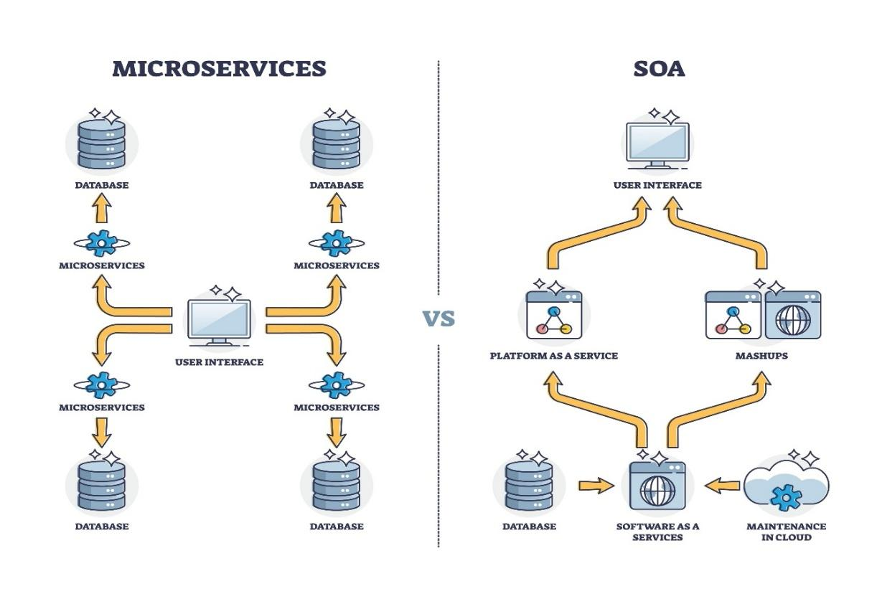
2.4 DevOps and CI/CD
The development of the LGU Disaster Preparedness system utilizes DevOps practices to bridge the gap between software development and IT operations. This ensures that the platform is not only built efficiently but also remains stable, secure, and easily updatable as new disaster simulation needs arise.
Continuous Integration and Continuous Delivery (CI/CD)
The project employs a CI/CD pipeline to automate the path from code commit to deployment.
- Continuous Integration (CI): Every time a developer commits code to the repository, automated builds and unit tests are triggered to ensure that new changes do not break existing functionality.
- Continuous Delivery (CD): Once the code passes the testing phase and is approved, it is automatically merged and deployed to the staging or production environments, allowing for a rapid and reliable release cycle.

Infrastructure as Code (IaC)
To maintain consistency across development, staging, and production environments, the team uses Infrastructure as Code (IaC).
- This approach defines the cloud infrastructure (such as servers and network configurations) through machine-readable files rather than manual configuration.
- By treating infrastructure like application code, the team can provision and manage environments automatically through the CI/CD pipeline, reducing human error and ensuring environment parity.

Monitoring and Alerting
Maintaining high availability for a disaster training platform is critical. The project implements a comprehensive Monitoring and Alerting strategy using a Kubernetes-based stack:
- Metric Collection: Tools like Prometheus collect real-time data from the system, including server health and application performance.
- Visualization: Grafana is utilized to create dashboards that visualize system metrics for the development and operations team.
- Real-time Alerting: An Alertmanager is configured to send immediate notifications to communication channels, such as Microsoft Teams, if the system encounters errors or performance degradation, ensuring a proactive response to technical issues.

2.5 Relevant Studies and Research
The transition toward intelligent disaster risk reduction and management (DRRM) requires a shift from static, paper-based protocols to dynamic, automated systems. Current research highlights that localized readiness is often the "weak link" in national resilience, and modern software architectures combined with Large Language Models (LLMs) are now the primary solution for bridging this gap.
Local Studies
Baltazar, Florencio, Vicente, and Belizario (2024), in their study "The Role of Artificial Intelligence in Disaster Prediction, Mitigation, and Response in the Philippines: Challenges and Opportunities," confirm that while the Philippine government has integrated AI into national frameworks, local-level adoption is hindered by infrastructure and budget constraints. Their findings advocate for AI-driven initiatives that can assist in post-disaster assessments and enhance the accuracy of localized early warning protocols.
Philippine Institute for Development Studies [PIDS] (2025), in the updated report "Disaster Preparedness and Local Governance in the Philippines," notes that even with strong laws like RA 10121, there remains a disconnect in how national policies "cascade" to the subnational and LGU levels. The study concludes that for resilience to be effective, local governance must be supported by functional tools that translate theoretical policy into actionable, simulated exercises.
Foreign Studies
Wang, Wang, Zhang, and Zeng (2025), in the paper "Towards Intelligent Emergency Management: A Scenario Learning Decision Framework Enabled by Large Language Models," demonstrate that LLMs can construct evolving emergency contexts, including evacuation routes and situational graphs. Their research validates that AI-generated scenarios move beyond the governance challenges of "fragmented strategies and cognitive disconnection" found in traditional, human-led drills.
Narváez, Battaglia, Fernández, and Rossi (2025), in their systematic literature review "Designing Microservices Using AI," analyze how decoupled architectures optimize performance and mitigate the inherent complexities of scalable systems. Their study provides the technical justification for using microservices in public safety applications, as it ensures fault isolation and independent deployability critical for keeping government training portals available during emergencies.
2.6 Integration of Information Systems in Enterprise Environment
The successful deployment of the LGU Disaster Preparedness system requires integrating the new platform with existing LGU data sources and external technologies (like the Gemini API). This section describes the methods used and the common challenges encountered when linking disparate systems to form a cohesive enterprise solution.

A. Core Objectives of Integration
Integration aims to ensure seamless data flow, process consistency, and application interoperability across the enterprise. For the LGU project, the main objectives are:
1. Unified Data Access: Allowing the simulation platform to access crucial LGU datasets (e.g., population density, asset locations) for accurate scenario generation.
2. Process Automation: Automating the handover of training results from the simulation platform to the LGU's HR/Training records system.
3. Real-Time Interoperability: Enabling the dynamic, two-way communication required to send prompts to the Gemini API and receive scenario text in real time.

B. Key Integration Methods
The microservices architecture chosen for this project naturally aligns with modern, loosely coupled integration patterns:
1. Service-Oriented Architecture (SOA) / API Gateway:
- Method: Utilizing APIs (Application Programming Interfaces) as the standardized communication mechanism between systems.
- Application: Our microservices communicate with each other and with the Gemini API using RESTful APIs. An API Gateway acts as a single entry point for all external access, managing security and routing traffic to the correct service.
2. Database Integration (For Legacy Systems):
- Method: Directly accessing or replicating data from a legacy system's database.
- Challenge: This is generally avoided in microservices, but may be necessary if the LGU has old, critical systems that cannot expose data via an API. It creates tight coupling and complexity.
3. Message Passing / Event-Driven Architecture (EDA):
- Method: Systems communicate asynchronously by sending "events" (messages) through a central Message Broker (e.g., Kafka, RabbitMQ).
- Application: This is ideal for handling non-immediate data flow, such as sending a log of a completed training session to the LGU's central logging system without needing an immediate response.

C. Integration Challenges in the LGU Environment
Successfully integrating the system requires overcoming several common enterprise challenges:
1. Technical Diversity (Heterogeneity):
- Challenge: Integrating systems built on different technologies (e.g., a modern cloud-based platform vs. an older LGU system written in a legacy language).
- Mitigation: Standardizing on JSON/XML data formats and RESTful API contracts acts as a universal translator between technologies.
2. Data Semantic Inconsistency:
- Challenge: Different systems may use the same term to mean different things (e.g., one system defines "Citizen ID" differently than another).
- Mitigation: Developing a unified Canonical Data Model that acts as the single source of truth for key LGU entities (Personnel, Assets, Hazards).
3. Security and Governance:
- Challenge: Ensuring secure data transmission and authentication across systems, especially when involving sensitive LGU citizen data or proprietary external APIs (like Gemini).
- Mitigation: Implementing the API Gateway to enforce security policies (like OAuth 2.0 authentication) and encrypting all data transmission via TLS/SSL.

Chapter 3
METHODOLOGY
3.1 Agile Scrum Methodology in the Project
The Agile Scrum Framework was selected to manage the development of the LGU Disaster Preparedness system. Scrum is an empirical, iterative, and incremental approach designed to manage complex projects, providing the flexibility needed to handle evolving requirements, integrate new technologies (like the Gemini API), and adapt to stakeholder feedback from the Local Government Unit (LGU).

A. Core Principles Applied
The project adhered to the core pillars of Scrum:
- Transparency: All work, progress, and issues (the Product Backlog and Sprint Backlog) were visible to the Development Team, the Product Owner (LGU representative), and the Scrum Master.
- Inspection: Progress was regularly inspected through the Daily Scrum and the Sprint Review meeting.
- Adaptation: The team continuously adapted its process and plan in the Sprint Retrospective based on what was learned during the previous iteration.

B. Project Roles and Responsibilities
The three defined Scrum roles were essential for managing the project's scope and quality (as detailed in Section 3.2):
- Product Owner: Acted as the voice of the LGU client, prioritizing features that maximized value (e.g., prioritizing flood scenarios over drought scenarios based on LGU risk analysis).
- Scrum Master: Facilitated the Scrum process, coached the team, and removed impediments, particularly technical blockers related to API key management or cloud dependencies.
- Development Team: A self-organizing, cross-functional group responsible for all tasks, including designing the architecture, writing code, and performing integration testing of the Gemini API.

C. The Scrum Events (Meetings)
The project utilized the five standard Scrum events to structure work into focused iterations called Sprints (typically two weeks long):
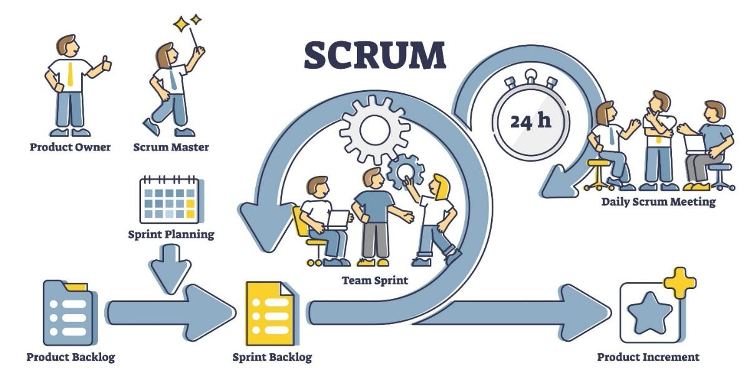
Figure no. 1 Agile Scrum Framework
1. Sprint Planning: The team met to select the highest priority items from the Product Backlog and define the Sprint Goal (e.g., "Implement the successful generation and display of a basic fire-related scenario").
2. Daily Scrum (Stand-up): A brief, 15-minute meeting held daily to inspect progress toward the Sprint Goal, identify any immediate roadblocks (impediments), and synchronize work.
3. Development Work: The team built the features, integrated the Gemini API, and conducted continuous testing.
4. Sprint Review: A formal meeting where the team demonstrated the "Done" Increment (e.g., a working scenario auto-generation feature) to the Product Owner and LGU stakeholders to gather feedback.
5. Sprint Retrospective: An internal team meeting to inspect how the last Sprint went regarding people, relationships, tools, and processes, leading to concrete improvements for the next Sprint.

D. Artifacts (Work Products)
Three key artifacts were maintained to track and manage the project:
- Product Backlog: A prioritized, dynamic list of all known features, functions, requirements, and enhancements needed for the LGU Training System.
- Sprint Backlog: The subset of the Product Backlog selected for the current Sprint, plus the plan for delivering the Increment.
- Increment: The usable, integrated result of all Sprint Backlog items completed during the Sprint and all previous Sprints, which was always in a potentially shippable state.
The adoption of Scrum ensured that the capstone project delivered a high-value, working solution that constantly incorporated the LGU's needs and technical findings from the Gemini API integration.

3.2 Roles and Responsibilities
Each role in the project team carries significant responsibilities that directly influence the success and overall performance of the capstone project. The table below outlines the key duties assigned to each team member:
Name | Role | Responsibilities
Ms. Richelyn Villasor | Research Adviser | Provides academic guidance and technical oversight. Responsible for reviewing the methodology, ensuring the project meets institutional standards, and approving the final documentation
Barangay San Agustin | Product Owner | Represents the end-user (LGU). Defines the specific disaster scenarios needed, provides feedback on the simulation accuracy, and ensures the tool addresses real-world emergency gaps.
REYMON S.A BROGADA | Project Manager | Oversees the project timeline and task distribution. Ensures that milestones for the simulation engine and documentation are met and coordinates communication between the team and stakeholders.
JOHN BENEDICT S. FANER | Developer/Lead Programmer | Responsible for the core development of the system. Handles the integration of the Gemini API for scenario generation and manages the Firebase database for real-time data storage.
ERIC A. PASTOR | QA Tester | Conducts rigorous testing of the scenario generator. Responsible for identifying bugs, ensuring the logic of the AI outputs remains consistent, and verifying that the user interface is functional.
CHEINARD R. AQUINO | Documentation Specialist | Manages all written deliverables, including the Capstone Manuscript. Responsible for documenting the system architecture, user manuals, and keeping a record of all project revisions.
MARC DAVE S. VALDEZ | Security Lead | Ensures the integrity and security of the system. Responsible for managing Firebase authentication, protecting API keys, and ensuring that any LGU data stored is encrypted and secure.
Table no.1 Roles and Responsibilities

3.3 Sprint Cycles
Sed ut perspiciatis unde omnis iste natus error sit voluptatem accusantium doloremque laudantium, totam rem aperiam, eaque ipsa quae ab illo inventore veritatis et quasi architecto beatae vitae dicta sunt explicabo.
To Do | In Progress | Done
Table no. 2 Scrum Board

3.4 Scrum Artifacts
3.4.1 Product Backlog (User Stories)
User Story No. | Features/ Task | User Stories | Priority | Status
MODULE 1
F1 | User Registration System | As a user/admin, I want to register accounts and verify emails to access the platform | High | ✅ Completed
F2 | Multi-Role Authentication | As a user, I want secure login (OTP/USB) and role-based access to ensure data security. | High | ✅ Completed
F10 | User Profile Management | As a user, I want to manage my profile and security settings to keep my information up to date. | Medium | ✅ Completed
MODULE 2
F11 | Training Module Management | As an admin, I want to create and manage lessons and resources to provide educational content. | High | ✅ Completed
F20 | Scenario-Based Exercise Design | As an admin, I want to design AI-powered scenarios to simulate realistic training environments. | High | ✅ Completed
MODULE 3
F21 | Simulation Event Planning | As an admin, I want to schedule and manage events so participants can register for sessions. | Medium | ✅ Completed
F30 | Participant Registration & Attendance | As a participant, I want to register for events and check-in to track my attendance. | Medium | ✅ Completed
MODULE 4
F31 | Evaluation & Scoring System | As an admin, I want to score participants based on criteria to determine their pass/fail status. | High | ✅ Completed
F40 | Certification Issuance | As a successful participant, I want to receive and verify a certificate for my accomplishments. | High | 🚧 In Progress
Table no. 3 Product Backlog

3.4.2 Product Backlog for EIS Information Security
EIS No. | EIS User Stories | EIS IS Priority | Revision Priority | Status
IS-1 | Implement secure authentication mechanisms (OTP, USB Key) | 1 | 1 | ✅ Completed
IS-2 | Role-based access control (RBAC) implementation | 1 | 2 | ✅ Completed
IS-3 | Audit logging for all system actions | 1 | 2 | ✅ Completed
IS-4 | Session management and timeout | 1 | 1 | ✅ Completed
IS-5 | Password policy enforcement | 1 | 2 | 🚧In Progress
IS-6 | Data encryption at rest | 2 | 3 | 📋 Planned
IS-7 | Data encryption in transit (HTTPS) | 1 | 1 | ✅ Completed
IS-8 | SQL injection prevention | 1 | 1 | ✅ Completed
IS-9 | XSS (Cross-Site Scripting) protection | 1 | 1 | ✅ Completed
IS-10 | CSRF (Cross-Site Request Forgery) protection | 1 | 1 | ✅ Completed
IS-11 | Rate limiting and brute force protection | 1 | 1 | ✅ Completed
IS-12 | Secure file upload validation | 2 | 2 | ✅ Completed
IS-13 | Input validation and sanitization | 1 | 1 | ✅ Completed
IS-14 | Security headers implementation | 2 | 2 | 📋 Planned
IS-15 | Regular security audits and penetration testing | 3 | 3 | 📋 Planned
Table no. 4 Product Backlog for EIS Information Security
3.4.3 Product Backlog for EIS Standards
3.4.3.1 UI/UX (Icons, Color, etc…)
EIS Standard No. | EIS Standard User Stories | EIS Standard Priority | Revision Priority | Status
UI-1 | Implement consistent color palette (Primary: Teal, Secondary: Slate) | 1 | 1 | ✅ Completed
UI-2 | Establish icon system using Lucide React icons | 1 | 1 | ✅ Completed
UI-3 | Create responsive design standards (Mobile-first approach) | 1 | 1 | ✅ Completed
UL-4 | Implement consistent typography system | 1 | 1 | ✅ Completed
UL-5 | Design reusable component library | 1 | 1 | ✅ Completed
UL-6 | Create consistent spacing and layout system | 1 | 1 | ✅ Completed
UL-7 | Implement loading states and skeleton screens | 2 | 2 | ✅ Completed
UL-8 | Design error and success message components | 1 | 1 | ✅ Completed
UL-9 | Create consistent form input styling | 1 | 1 | ✅ Completed
UL-10 | Implement consistent button styles and states | 1 | 1 | ✅ Completed
UL-11 | Design modal and dialog components | 1 | 1 | ✅ Completed
UL-12 | Create consistent table and data display components | 1 | 1 | ✅ Completed
UL-13 | Implement dark mode support | 3 | 3 | 📋 Planned
UL-14 | Accessibility compliance (WCAG 2.1 AA) | 2 | 2 | 🚧 In Progress
UL-15 | Create design system documentation | 2 | 2 | 📋 Planned
Table no. 5 Product Backlog for EIS Standards

3.4.4 Product Backlog for EIS Integration
EIS Integration No. | EIS Integration User Stories | EIS Integration Priority | Revision Priority | Status
INT-1 | Certification Tracking System Integration | 1 | 1 | 🚧 In Progress
INT-2 | External Certification Authority API Integration | 1 | 1 | 📋 Planned
INT-3 | Certificate Verification Service Integration | 1 | 1 | 📋 Planned
INT-4 | Email Service Integration (SMTP/SendGrid) | 1 | 1 | ✅ Completed
INT-5 | SMS Notification Integration (Twilio/Vonage) | 2 | 2 | 📋 Planned
INT-6 | File Storage Integration (AWS S3/Local) | 1 | 1 | ✅ Completed
INT-7 | Payment Gateway Integration (for future use) | 3 | 3 | 📋 Planned
INT-8 | Reporting System Integration | 2 | 2 | 📋 Planned
INT-9 | Analytics Platform Integration | 2 | 2 | 📋 Planned
INT10 | Single Sign-On (SSO) Integration | 3 | 3 | 📋 Planned
Table no. 6 Product Backlog for EIS Integration
3.4.5 Product Backlog for Analytics
3.4.5.1 Application System Analytics
EIS Integration No. | EIS Integration User Stories | EIS Integration Priority | Revision Priority | Status
ASA-1 | User Activity Analytics Dashboard | 1 | 1 | ✅ Completed
ASA-2 | Training Module Completion Analytics | 1 | 1 | ✅ Completed
ASA-3 | Event Participation Analytics | 1 | 1 | ✅ Completed
ASA-4 | Evaluation Performance Analytics | 1 | 1 | ✅ Completed
ASA-5 | Certification Issuance Analytics | 1 | 1 | 🚧 In Progress
ASA-6 | User Engagement Metrics | 2 | 2 | 📋 Planned
ASA-7 | System Usage Statistics | 2 | 2 | 📋 Planned
ASA-8 | Performance Trend Analysis | 2 | 2 | 📋 Planned
ASA-9 | Custom Report Builder | 3 | 3 | 📋 Planned
ASA-10 | Real-time Dashboard Updates | 2 | 2 | ✅ Completed
Table no. 7 Product Backlog for Analytics
3.4.5.2 EIS Analytics
EIS Analytics No. | EIS Analytics Stories | EIS Analytics Priority | Revision Priority | Status
EA-1 | Security Event Analytics | 1 | 1 | ✅ Completed
EA-2 | Login Attempt Analytics | 1 | 1 | ✅ Completed
EA-3 | User Access Pattern Analysis | 2 | 2 | ✅ Completed
EA-4 | Audit Log Analytics | 1 | 1 | ✅ Completed
EA-5 | Failed Authentication Tracking | 1 | 1 | ✅ Completed
EA-6 | Session Duration Analytics | 2 | 2 | ✅ Completed
EA-7 | User Activity Monitoring | 1 | 1 | ✅ Completed
EA-8 | Security Incident Reporting | 2 | 2 | 📋 Planned
EA-9 | Compliance Reporting | 3 | 3 | 📋 Planned
EA-10 | Risk Assessment Analytics | 3 | 3 | 📋 Planned
Table no.8 EIS Analytics

3.4.6 Sprint Backlog (User Stories)
Task No. | User Story No. | User Stories | Tasks | Timeline | Responsible Team Member/s
SPRINT 1
S1_1 | IS-1 | Implement secure authentication mechanisms | PLANNING  DESIGN  CODE  DOCUMENTATION | Week 1-2 | Backend Developer, Frontend Developer
S1_2 | IS-2 | Role-based access control implementation | PLANNING  DESIGN  CODE  TESTING | Week 1-2 | Backend Developer, Security Specialist
S1_3 | F-1 | User registration system | PLANNING  DESIGN  CODE  TESTING | Week 1-2 | Full-stack Developer
S1_4 | F2 | Multi-role authentication | PLANNING  DESIGN  CODE  TESTING | Week 1-2 | Backend Developer
S1_5 | IS-4 | Session management and timeout | PLANNING  DESIGN  CODE  TESTING | Week 2 | Backend Developer
SPRINT 2
S2_1 | IS-3 | Audit logging for all system actions | PLANNING  DESIGN  CODE  DOCUMENTATION | Week 3-4 | Backend Developer
S2_2 | F11 | Training module management | PLANNING  DESIGN  CODE  TESTING | Week 3-4 | Full-stack Developer
S2_3 | F20 | Scenario-based exercise design | PLANNING  DESIGN  CODE  TESTING | Week 3-4 | Full-stack, AI Specialist
S2_4 | UL-1 TO 6 | UI/UX standards implementation | PLANNING  DESIGN  CODE  TESTING | Week 3-4 | Frontend Dev, UI/UX Designer
S2_5 | F21 | Simulation event planning | PLANNING  DESIGN  CODE  TESTING | Week 4 | Full-stack Developer
SPRINT 3
S3_1 | F30 | Participant registration & attendance | PLANNING  DESIGN  CODE  TESTING | Week 5-6 | Full-stack Developer
S3_2 | ASA-1 | User activity analytics | PLANNING  DESIGN  CODE  TESTING | Week 5-6 | Backend, Frontend Developer
S3_3 | EA-7 | User activity monitoring | PLANNING  DESIGN  CODE  TESTING | Week 5-6 | Backend Developer
S3_4 | UL-7 TO 12 | Additional UI components | PLANNING  DESIGN  CODE  TESTING | Week 6 | Frontend Developer
S3_5 | INT-6 | File storage integration | PLANNING  DESIGN  CODE  TESTING | Week 6 | Backend Developer
SPRINT 4
S4_1 | F31 | Evaluation & scoring system | PLANNING  DESIGN  CODE  TESTING | Week 7-8 | Full-stack Developer
S4_2 | ASA-4 | Evaluation performance analytics | PLANNING  DESIGN  CODE  TESTING | Week 8 | Backend, Frontend Developer
S4_3 | EA-4 | Audit log analytics | PLANNING  DESIGN  CODE  TESTING | Week 8 | Backend Developer
S4_4 | ASA-3 | Event participation analytics | PLANNING  DESIGN  CODE  TESTING | Week 8 | Backend Developer
S4_5 | UL-14 | Accessibility compliance | PLANNING  DESIGN  CODE  TESTING | Week 8 | Frontend Dev, QA Specialist
SPRINT 5
S5_1 | INT-1 | Certification tracking integration | PLANNING  DESIGN  CODE  TESTING | Week 9-10 | Full-stack, Backend Developer
S5_ | F40 | Certification issuance | PLANNING  DESIGN  CODE  TESTING | Week 9-10 | Full-stack Developer
S5_3 | ASA-5 | Certification issuance analytics | PLANNING  DESIGN  CODE  TESTING | Week 10 | Backend Developer
S5_4 | INT-3 | Certificate verification service | PLANNING  DESIGN  CODE  TESTING | Week 10 | Backend, Frontend Developer
S5_5 | INT-2 | External cert authority API | PLANNING  DESIGN  CODE  TESTING | Week 10 | Backend, Integration Spec.
SPRINT 6
S6_1 | ASA-6 | User engagement metrics | PLANNING  DESIGN  CODE  TESTING | Week 11-12 | Backend Dev, Data Analyst
S6_2 | ASA-7 | System usage statistics | PLANNING  DESIGN  CODE  TESTING | Week 11-12 | Backend Developer
S6_3 | ASA-8 | Performance trend analysis | PLANNING  DESIGN  CODE  TESTING | Week 12 | Data Analyst, Frontend Dev
S6_4 | ASA-9 | Custom report builder | PLANNING  DESIGN  CODE  TESTING | Week 12 | Full-stack Developer
S6_5 | INT-8 | Reporting system integration | PLANNING  DESIGN  CODE  TESTING | Week 12 | Backend Developer
SPRINT 7
S7_1 | INT-5 | SMS notification integration | PLANNING  DESIGN  CODE  TESTING | Week 13-14 | Backend Developer
S7_2 | INT-9 | Analytics platform integration | PLANNING  DESIGN  CODE  TESTING | Week 13-14 | Backend Dev, Data Analyst
S7_3 | INT-10 | SSO integration | PLANNING  DESIGN  CODE  TESTING | Week 14 | Backend, Security Specialist
S7_4 | EA-8 | Security incident reporting | PLANNING  DESIGN  CODE  TESTING | Week 14 | Backend Developer
S7_5 | API DOCS | RESTful API documentation | PLANNING  DESIGN  CODE  TESTING | Week 14 | Backend Dev, Tech Writer
SPRINT 8
S8_1 | UL-13 | Dark mode support | PLANNING  DESIGN  CODE  TESTING | Week 15-16 | Frontend Dev, UI Designer
S8_2 | UL-15 | Design system documentation | PLANNING  DESIGN  CODE  TESTING | Week 15-16 | UI Designer, Tech Writer
S8_3 | PERF-1 | System performance optimization | PLANNING  DESIGN  CODE  TESTING | Week 16 | Full-stack Dev, DevOps
S8_4 | EA-9 | Compliance reporting | PLANNING  DESIGN  CODE  TESTING | Week 16 | Backend, Compliance Spec.
S8_5 | QA-FINAL | Comprehensive system testing | PLANNING  TESTING  FIXES  DOCS | Week 16 | QA Team, All Developers

Table no. 9 Sprint Backlog (User Stories)

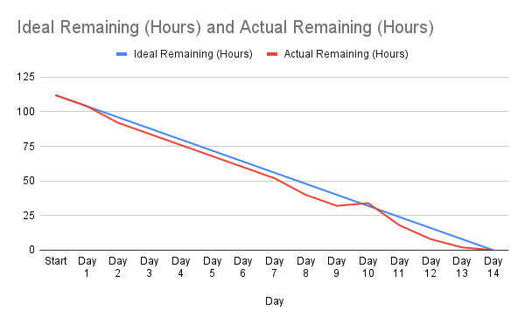
3.4.6.1 Sprint Burndown Chart

Figure no. 2 Burndown Chart

3.4.7. Increment
Sprint No. | Increment / Feature Delivered |  | User Story / Backlog Reference | Definition of Done (DoD) Criteria | Status | Remarks
Sprint 1 | User Registration & Login Module | IS-1, IS-2 |  | Code completed  - Unit tested  - Integrated with DB  - Documentation updated | Done | Basic authentication working
Sprint 1 | Database Schema Setup | F-1 |  | - Schema created  - Tables normalized  - Tested with sample data | Done | Ready for integration
Sprint 2 | Product Catalog Module | IS-3, IS-4 |  | - UI designed  - CRUD operations functional  - Tested on staging | In Progress | Pending UI review
Sprint 2 | Shopping Cart | F-4 |  | - Add/remove items working  - Cart persists in session  - Unit tested | In Progress | Needs integration with checkout
Sprint 3 | Checkout & Payment Integration | IS-5, F-5 |  | - Payment gateway connected  - Security tested (SSL)  - Error handling in place | Planned | To be developed in Sprint 3

Table no. Increment

3.5 Microservices Architecture
orem ipsum dolor sit amet, consectetur adipiscing elit, sed do eiusmod tempor incididunt ut labore et dolore magna aliqua. Ut enim ad minim veniam, quis nostrud exercitation ullamco laboris nisi ut aliquip ex ea commodo consequat. Duis aute irure dolor in reprehenderit in voluptate velit esse cillum dolore eu fugiat nulla pariatur.
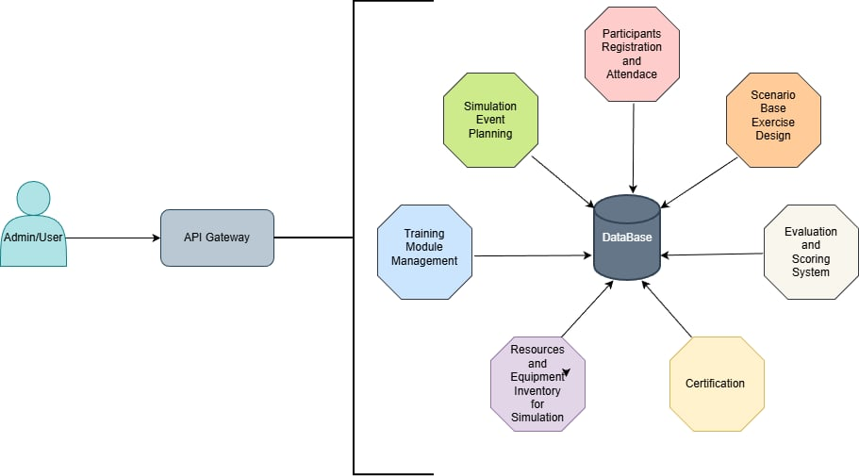

Figure no. 3 Microservices Diagram

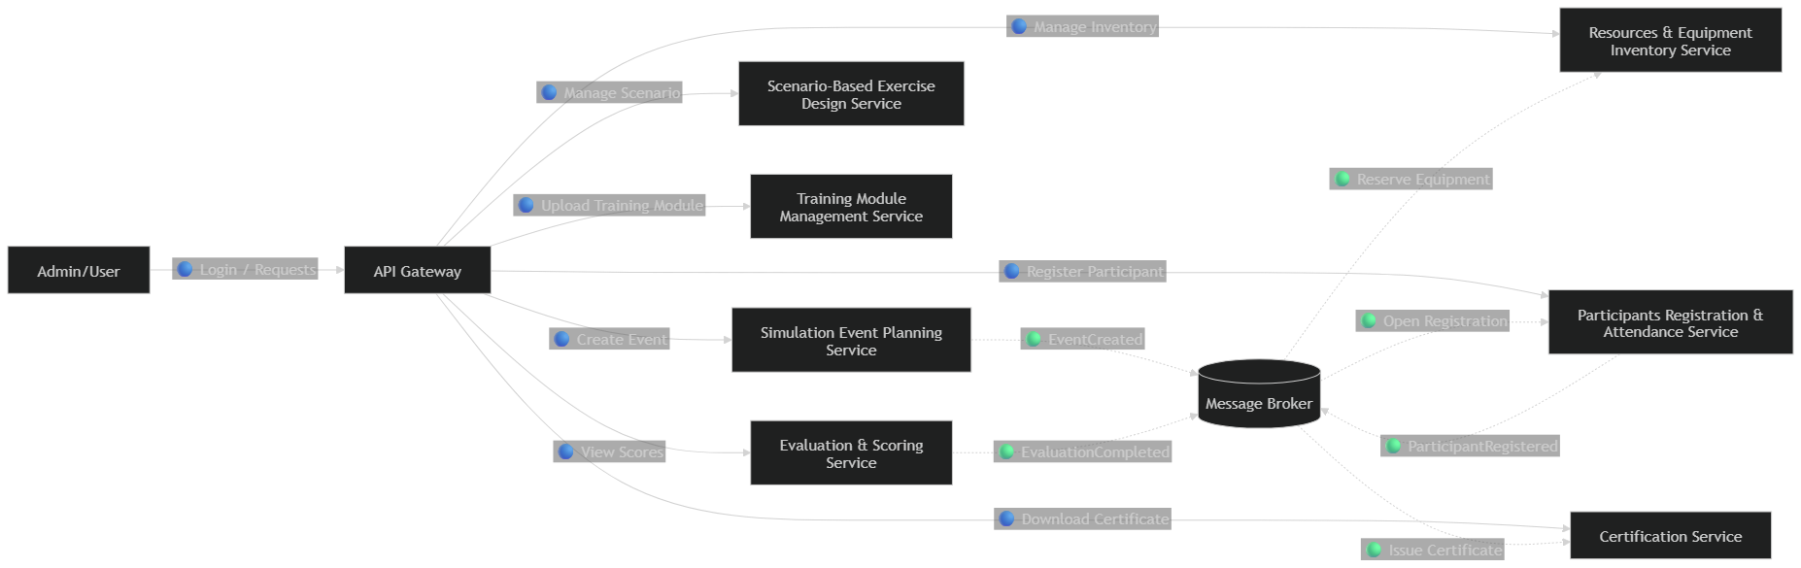
Figure no. 4 Communication Pattern for Microservices
Here’s the communication pattern diagram for an e-commerce microservices system:
🔵 Blue solid lines → Synchronous (Request/Response)
🟢 Green dashed lines → Asynchronous (Event-driven via Message Broker)

Dfd level 1
Level 1 DFD (Context Diagram)
This shows the entire e-commerce system as one process and how external entities interact with it.
- External Entity: Customer
- System (Process): E-commerce Microservices System
- Data Stores: Account DB, Inventory DB, Order DB, Payment DB
- Data Flows: Login, Browse Products, Place Order, Make Payment, Receive Notification, Shipping Info
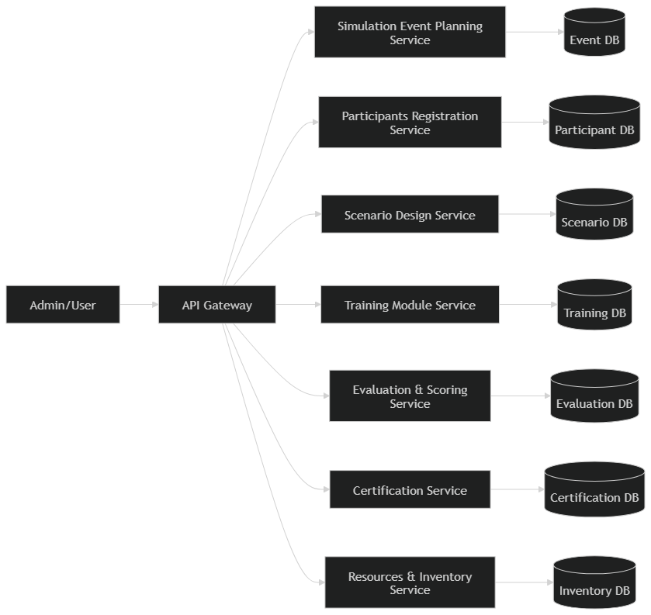
Figure no. 5 Data Flow Diagram for Microservices

3.6 DevOps Implementation
Lorem ipsum dolor sit amet, consectetur adipiscing elit, sed do eiusmod tempor incididunt ut labore et dolore magna aliqua. Ut enim ad minim veniam, quis nostrud exercitation ullamco laboris nisi ut aliquip ex ea commodo consequat. Duis aute irure dolor in reprehenderit in voluptate velit esse cillum dolore eu fugiat nulla pariatur.
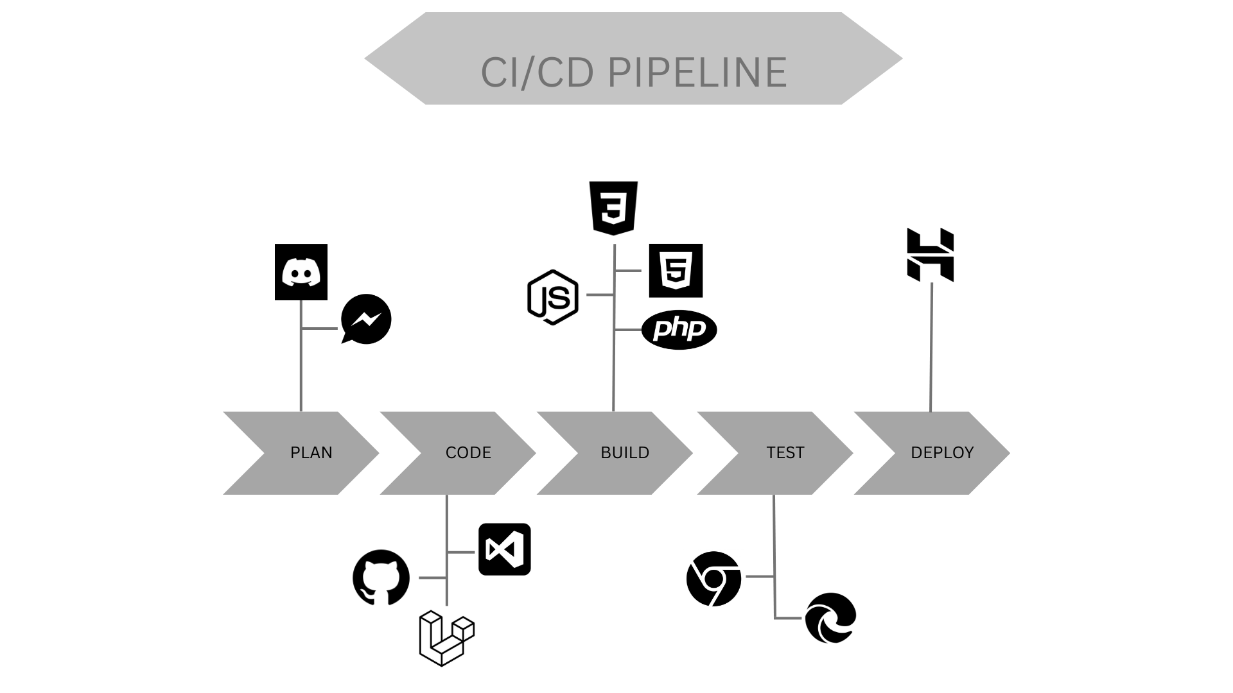
Figure no. 6 CI/CD Pipeline
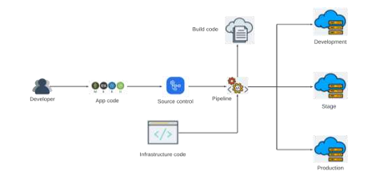
Figure no. 7 Infrastructure as a Code (IaC)

Lorem ipsum dolor sit amet, consectetur adipiscing elit, sed do eiusmod tempor incididunt ut labore et dolore magna aliqua. Ut enim ad minim veniam, quis nostrud exercitation ullamco laboris nisi ut aliquip ex ea commodo consequat. Duis aute irure dolor in reprehenderit in voluptate velit esse cillum dolore eu fugiat nulla pariatur. Excepteur sint occaecat cupidatat non proident, sunt in culpa qui officia deserunt mollit anim id est laborum

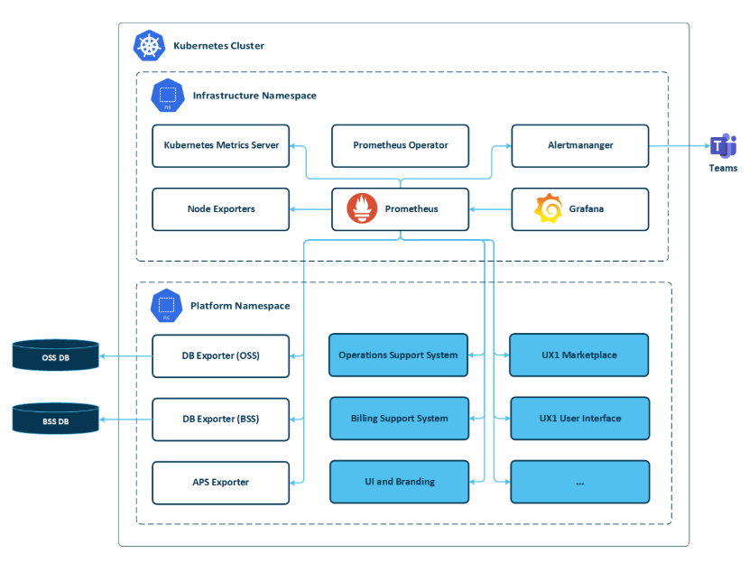
Figure no. 8 Monitoring and Alerting
Lorem ipsum dolor sit amet, consectetur adipiscing elit, sed do eiusmod tempor incididunt ut labore et dolore magna aliqua. Ut enim ad minim veniam, quis nostrud exercitation ullamco laboris nisi ut aliquip ex ea commodo consequat. Duis aute irure dolor in reprehenderit in voluptate velit esse cillum dolore eu fugiat nulla pariatur. Excepteur sint occaecat cupidatat non proident, sunt in culpa qui officia deserunt mollit anim id est laborum

3.7 Integration Approach for Information Systems
The integration approach for the information systems developed Lorem ipsum dolor sit amet, consectetur adipiscing elit, sed do eiusmod tempor incididunt ut labore et dolore magna aliqua. Ut enim ad minim veniam, quis nostrud exercitation ullamco laboris nisi ut aliquip ex ea commodo consequat. Duis aute irure dolor in reprehenderit in voluptate velit esse cillum dolore eu fugiat nulla pariatur. Excepteur sint occaecat cupidatat non proident, sunt in culpa qui officia deserunt mollit anim id est laborum
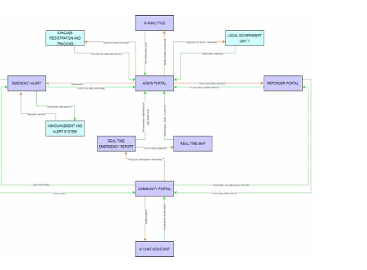
Figure no. 9 Business Process Architecture
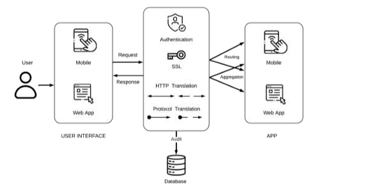
Figure no. 10 API Gateway
Lorem ipsum dolor sit amet, consectetur adipiscing elit, sed do eiusmod tempor incididunt ut labore et dolore magna aliqua. Ut enim ad minim veniam, quis nostrud exercitation ullamco laboris nisi ut aliquip ex ea commodo consequat. Duis aute irure dolor in reprehenderit in voluptate velit esse cillum dolore eu fugiat nulla pariatur. Excepteur sint occaecat cupidatat non proident, sunt in culpa qui officia deserunt mollit anim id est laborum

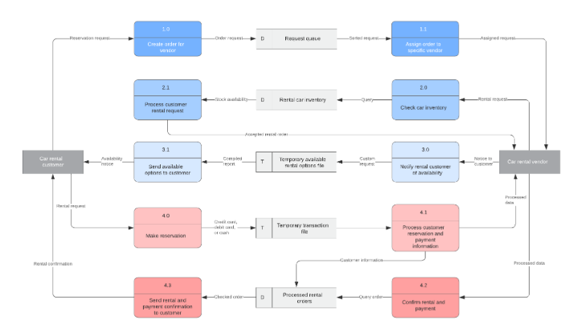
Figure no. 11 Data Flow Diagram
Lorem ipsum dolor sit amet, consectetur adipiscing elit, sed do eiusmod tempor incididunt ut labore et dolore magna aliqua. Ut enim ad minim veniam, quis nostrud exercitation ullamco laboris nisi ut aliquip ex ea commodo consequat. Duis aute irure dolor in reprehenderit in voluptate velit esse cillum dolore eu fugiat nulla pariatur. Excepteur sint occaecat cupidatat non proident, sunt in culpa qui officia deserunt mollit anim id est laborum
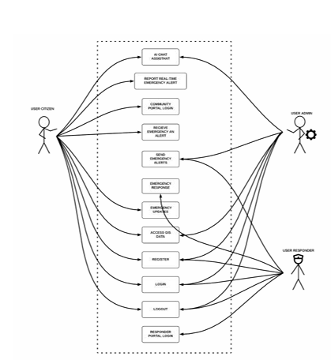
Figure no. 12 Use Case Diagram
Lorem ipsum dolor sit amet, consectetur adipiscing elit, sed do eiusmod tempor incididunt ut labore et dolore magna aliqua. Ut enim ad minim veniam, quis nostrud exercitation ullamco laboris nisi ut aliquip ex ea commodo consequat. Duis aute irure dolor in reprehenderit in voluptate velit esse cillum dolore eu fugiat nulla pariatur. Excepteur sint occaecat cupidatat non proident, sunt in culpa qui officia deserunt mollit anim id est laborum

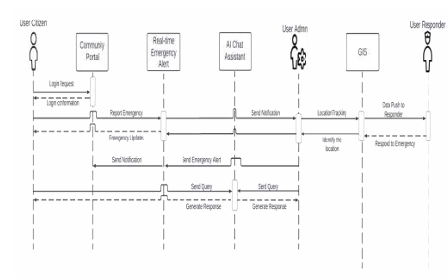
Figure no. 13 Sequence Diagram
Lorem ipsum dolor sit amet, consectetur adipiscing elit, sed do eiusmod tempor incididunt ut labore et dolore magna aliqua. Ut enim ad minim veniam, quis nostrud exercitation ullamco laboris nisi ut aliquip ex ea commodo consequat. Duis aute irure dolor in reprehenderit in voluptate velit esse cillum dolore eu fugiat nulla pariatur. Excepteur sint occaecat cupidatat non proident, sunt in culpa qui officia deserunt mollit anim id est laborum
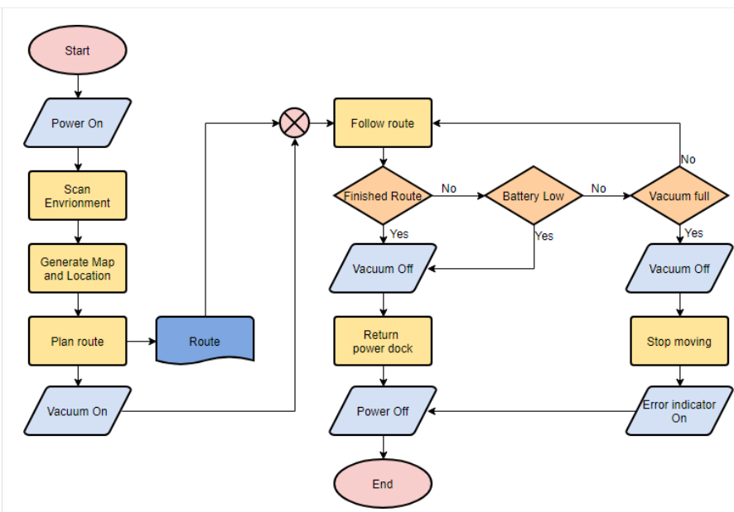
Figure no. 14 Flowchart
Lorem ipsum dolor sit amet, consectetur adipiscing elit, sed do eiusmod tempor incididunt ut labore et dolore magna aliqua. Ut enim ad minim veniam, quis nostrud exercitation ullamco laboris nisi ut aliquip ex ea commodo consequat. Duis aute irure dolor in reprehenderit in voluptate velit esse cillum dolore eu fugiat nulla pariatur. Excepteur sint occaecat cupidatat non proident, sunt in culpa qui officia deserunt mollit anim id est laborum

3.8 Introduction to TOGAF and the Four Architectural Domains
1. Business Architecture
Focus: This domain models existing disaster protocols, organizational hierarchy, and training needs based on the LGU's current manual (e.g., their specific response to a flood).
Goal: To ensure the simulation tool directly supports and improves the exact steps personnel must take during a real disaster.
Stakeholder Representation: The Product Owner (represented by Barangay San Agustin) defines the specific disaster scenarios and ensures the tool addresses real-world emergency gaps.
2. Data Architecture
Focus: This lens examines crucial information such as historical incident reports, LGU personnel lists, and hazard maps.
Goal: To design a data structure that allows the Gemini AI to pull in relevant real-world data for realistic scenarios and ensures training feedback is stored securely and accessibly.
Integration: A unified Canonical Data Model is used to mitigate semantic inconsistencies across different systems.
3. Application Architecture
Focus: This serves as the software blueprint, defining the training platform, reporting module, and how these components integrate.
Goal: To define precisely how the Gemini API is plugged into the main platform to minimize complexity and ensure reliable information exchange.
Design Pattern: The project uses a Microservices Architecture, breaking the system into specialized services (e.g., Authentication, Simulation Core, AI Scenario Generator) that communicate via APIs.

4. Technology Architecture
Focus: This covers the fundamental underlying technology, including cloud servers (such as Firebase), network connections, and programming languages.
Goal: To set technical standards for security and performance, ensuring the platform can handle multiple users without crashing.
Security Measures: Includes implementing an API Gateway to enforce security policies like OAuth 2.0 and encrypting data transmission via TLS/SSL.

CHAPTER IV
4 Requirements Analysis
4.1. Stakeholder Identification
4.2. Requirements Gathering Techniques
4.3. User Stories and Use Cases
4.4. Functional Requirements for Integration
5 Business Process Architecture
5.1. Identification of Business Processes
5.2. Business Process Diagrams
5.3. Alignment of Integrated System with
Business Processes
5.4. Business Process Improvements
6 Application Architecture
6.1. Components of Application Architecture
6.2. Application Architecture Diagrams
6.3. Integration of Software Modules
6.4. Communication and Interaction Patterns
7 Data Architecture
7.1. Data Sources and Types
7.2. Data Flow Diagrams
7.3. Data Storage and Management
7.4. Data Synchronization Across Systems
8 Technology Architecture
8.1 Technology Stack and Infrastructure
8.2 Software Technologies
8.3. Scalability and Performance Considerations
9 Development Process
9.1. Agile Scrum Roles and Responsibilities
9.2. Sprint Planning and Backlog Management
9.3. Sprint Execution and Deliverables
9.4. Challenges Faced In the Development Process
10 Implementation
10.1. Technical Implementation Details
10.2. Tools and Technologies Used
10.3. Code Integration and Interoperability
10.4. Integration Testing and Debugging
11 Testing and Quality Assurance
11.1. Testing Strategies and Methodologies
11.2. Test Cases and Test Data
11.3. Test Results and Bug Reports
11.4. Quality Assurance Measures
12 Results and Evaluation
12.1. Project Outcomes and Deliverables
12.2. Alignment with Project Objectives
12.3 Stakeholder and User Feedback
12.4. Lessons Learned
CHAPTER V
13 Conclusion
13.1. Key Takeaways and Summary
13.2. Project Achievements and Contributions
13.3. Future Work and Enhancements
13.4. Closing Remarks

APPENDICES
Appendix A : Detailed Technical Documentation
1. System Architecture
2. Information Systems Integration
3. Application Design and Development
4. Database Schema and Data Management:
5. Network Configuration
6. Deployment and Infrastructure
7. Security Measures:
8. Testing and Quality Assurance
9. System Monitoring and Maintenance:
10. APIs and Integration Points:
11. User Documentation:
12. Known Issues and Troubleshooting
13. Version Control and Source Code Repository
14. DevOps and Continuous Integration/Continuous Deployment (CI/CD):
15. Licensing and Open Source Libraries:
16. Performance Metrics and Monitoring:

Appendix B : Documents/URLs
1.Adviser Acceptance (signed)
2. Company Confirmation (signed)
3. Panel Evaluation and Signature (plus photo ops during defense)
4. Pilot Companies’ Background with proofs of interviews
5. Link to codes (good for 3 years)
6. Link to documentation (good for 3 years)
7. Link to demo video guide (good for 3 years

Appendix C: Certificate of Originality
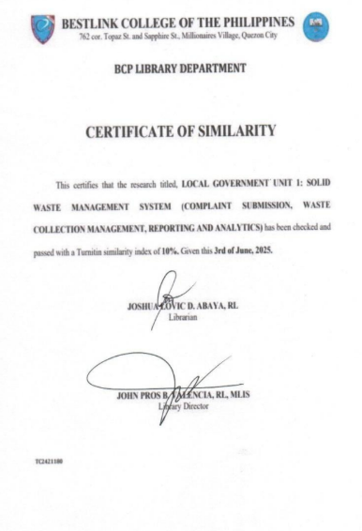

Appendix D: Certificate of Grammarian
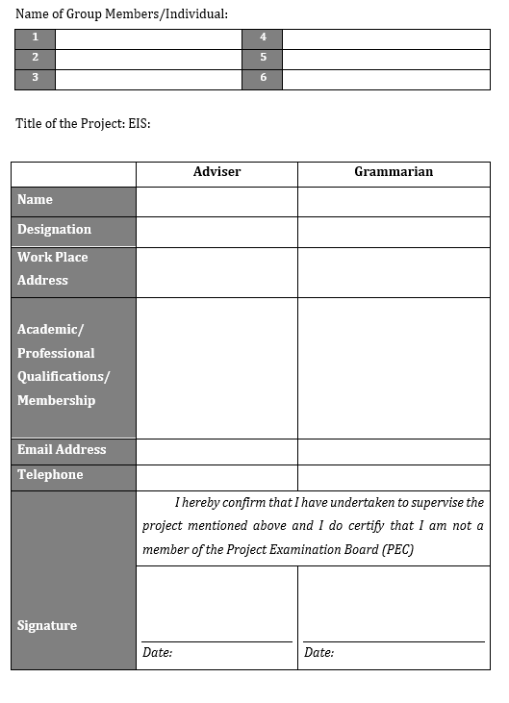
Appendix E : Grammarian Curriculum Vitae
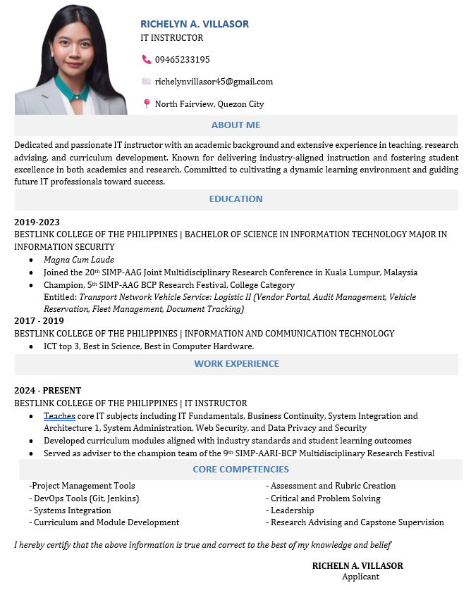
Appendix F : Technical Adviser Curriculum Vitae


Appendix G: Research Adviser Curriculum Vitae

Appendix H : Researcher’s Curriculum Vitae










